Design DB model for Guvi Zen class

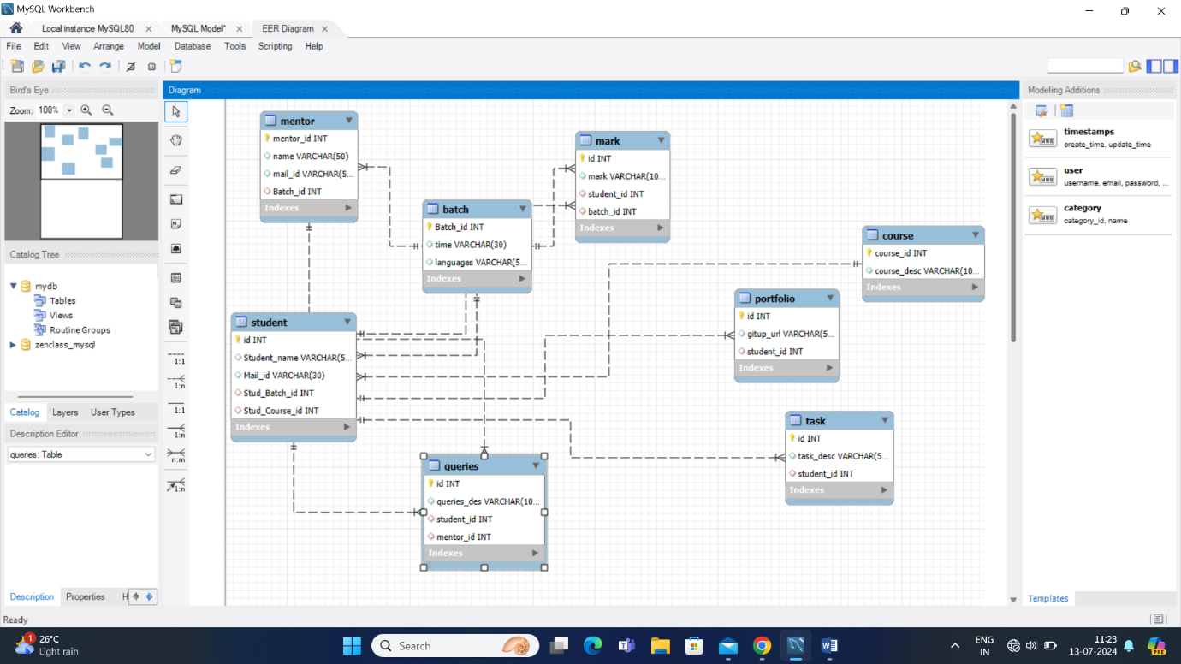

## **Code:**

create table batch(batch_id int primary key,time varchar(30),languages varchar(50));

create table course(course_id int primary key,course_desc varchar(100));

create table student(id int primary key, Student_name varchar(50), Mail_id varchar(30),Stud_Batch_id int,

Stud_Course_id int,

foreign key (Stud_Batch_id) references batch(Batch_id),

foreign key (Stud_Course_id) references course(course_id));

create table mentor(mentor_id int primary key,name varchar(50),mail_id varchar(50),Batch_id int,

foreign key (batch_id) references batch(batch_id));

create table Task(id int primary key,task_desc varchar(50),student_id int,

foreign key (student_id) references student(id));

create table portfolio(id int primary key,gitup_url varchar(50),student_id int,

foreign key (student_id) references student(id));

create table mark(id int primary key,mark varchar(100),student_id int,batch_id int,

foreign key (student_id) references student(id),

foreign key (batch_id) references batch(batch_id));

create table Queries(id int primary key ,queries_des varchar(100),student_id int,mentor_id int,

foreign key (student_id) references student(id),

foreign key (mentor_id) references mentor(mentor_id));

## 